Overview
The University of Texas MD Anderson Cancer Center is one of the world’s largest and most respected centers devoted exclusively to cancer patient care, research, education and prevention (QuickFacts, 2017). MD Anderson’s Mission is to eliminate cancer in the state of Texas and throughout the world. The facility fulfills its mission by conducting top-notch research, integrated patient care and prevention along with educating undergraduate and graduate students, employees and even the public (QuickFacts, 2017). The organization’s vision is to be the best cancer center in the world.
The lymphoma and myeloma clinic at MD Anderson upholds both the mission and vision of the institution. Historically, the employees at MD Anderson have always been content and are proud to work at such an esteemed facility. The work environment of the clinic in particular is extremely friendly and welcoming. The health professionals and administrators have a good relationship and strong team work is something the entire clinic is extremely proud of. The clinic proudly upholds MD Anderson’s core values; caring: striving to create a caring environment for everyone, integrity: “work together to merit the trust of colleagues and those we serve” and discovery: embrace creativity and seek new knowledge (QuickFacts, 2017). Per the core values, the staff and employees are constantly striving to provide better care and services for patients. However, friendliness, great staff and a welcoming work environment is not enough to sustain a clinic.
The associated clinic has been suffering financially as of late. Over the past five years, the clinic’s revenue has been on a steady decline. One of the main reasons for lower revenue has been claim denials from insurance companies, more specifically, denials from Medicare in particular. A large portion of the clinic’s patient population has listed Medicare as their primary or secondary payer. Out of all the claims denied at the facility, MD Anderson estimates that approximately 70% of denied claims are from Medicare (Ahmed, 2017). Upon further inspection, the clinic was able to hone in on one single issue largely affecting the reason behind claim denials: incorrectly filed MSPQ forms.
An MSPQ form is the Medicare as Secondary Payer Questionnaire. According to the article Incorrect or incomplete MSPQ? either way, it’s lost revenue the MSPQ is a requirement for all Medicare patients and registrations, recurring every 90 days (2017). If it is filled out incorrectly, the number of claim denials inevitably increase. The questionnaire itself is actually designed to cause frustrations among both patients and registrars resulting in further inaccuracies. A flaw of the MSPQ process is that the registrar has to dictate the questions in the form to the patients which leads to many inaccuracies while filling out the form. Dealing with MSPQ leads to a perpetual conflict between speed and accuracy vs. service (AHC Media, 2018). Experts even call the form a “clumsy document” that confuses and frustrates patients and healthcare providers alike (AHC Media, 2018). This document dates back to the 1980s with little to no updates or changes made in the past 40 years. And it is because of said document, the lymphoma and myeloma clinic at MD Anderson is facing financial adversaries.
The lymphoma and myeloma department has a total of 166 employees, including 25 physicians (Lymphoma & Myeloma, 2019). On average, the Lymphoma & Myeloma clinic sees about 100 patients in one day, accounting for no-shows (Ali, 2019). The clinic operates five days a week, thus the total patient yield on a weekly basis is 500. Appointments range from fast track blood draws, follow-ups and new patient evaluations. Follow-up appointments can be with research nurses for on-going clinical trials, mid-level providers and doctors. MSPQ are required for all patient visits. All new patient and certain follow-ups require extensive testing, such as MRI, PET scans and bone marrow biopsies which have the potential to generate large amounts of revenue. Therefore, MSPQs for these patients are of vital importance. Due to confidentiality purposes, financial data on patient appointments was not available, however estimates of procedure costs were found using the website MD Save. The succeeding chart lists the national average costs of each procedure. Given these costs and the weekly patient load, it is evident that Medicare denials can significantly affect revenue for the Lymphoma & Myeloma department.

Procedure | MRI | PET Scan | Bone Marrow Biopsy
Average Cost | $1,456 | $4,342 | $5,191

MD Anderson as a whole generates 78.2% of its net revenue from patients, i.e., from the patients’ insurance, out of pocket payments and Medicare and Medicaid (QuickFacts, 2019). These numbers are relevant for the lymphoma and myeloma clinic as well. If the clinic is not reimbursed through the Medicare patients, which is the majority of the patient volume, a loss is inevitable and for the past five years, the clinic has been on a trajectory towards a net loss. In terms of performance and service quality, the clinic has been ticking every box set out by MD Anderson. The service is top notch and the treatment is as good as it gets, but with a declining revenue, this may not be sustainable.
In order to tackle these Medicare claim denials and low reimbursement rates, the clinic has developed a new strategic plan revolving around accuracy while completing the MSPQ forms. In order to achieve a successful strategy, the clinic followed the hierarchy of strategic planning: Strategic positioning, service strategy, and tactical execution
Strategic Positioning
Strategic positioning sets out a corporate level set of objectives, goals, missions, etc. M D Anderson's Department of Lymphoma and Myeloma is one of the largest multidisciplinary programs treating these cancers of the blood in the U.S (mdanderson.org).
The Lymphoma and myeloma department at MD Anderson has been treating patients with these blood cancers, of which 70% of the patient flow have Medicare identified as primary or secondary payer. The department has been facing Medicare claim denials which directly affects the organization revenue and adds up to the expense to resubmit the claims. Of these denials, MSP (Medicare Secondary Payer) denials accounts for majority of the portion. The department aims to reduce the MSP denials by 10 % and consequently reduce overall Medicare claim denials by 1.4% for FY 2020. Under strategic positioning the department as well as the organization will be competing with all other organizations aiming to provide cancer treatment for patients covered under Medicare. The target market are all the current and potential patients requiring cancer treatment at MD Anderson covered under Medicare. Industry and Competitor Analysis Approach to Strategy would be used to develop strategic positioning. We would determine our external factors, i.e. our customers and competitors to improve our internal processes. Since a large portion of MD Anderson patients have Medicare coverage, they form a huge revenue to the organization. Developing strategies would focus on having accurate Medicare claims files to prevent loss of revenue. Among the internal factors would include change in the processes to gather maximum output. The five forces that have to be identified before developing the strategy are the potential Medicare patients, insurance companies, department staff, national benchmark and organization administrative department.
Driver Mission Connection:
MD Anderson's mission is to eliminate cancer in Texas, the nation and the world through outstanding programs that integrate patient care, research and prevention (Quickfacts, 2017). This mission relies heavily on high standards, process efficiency & revenue for its completion.

Goal Statement for Lymphoma and Myeloma Department:
Reduce MSPQ denials within the Department of Lymphoma and Myeloma by 10% for FY 2020.

Service Strategy
The service strategy involves setting up the service concept, the operating strategy and the service delivery system. A large portion is the service strategy is determining an organization’s competitive advantages. The biggest competitive advantage for the lymphoma and myeloma clinic is that it is directly under the MD Anderson system. This means all the benefits of a large organization such as MD Anderson applies to this department as well. A few strengths of MD Anderson as a whole include strong leadership, cutting edge research, high quality services and superior patient support. The lymphoma and myeloma department is able to use all of these strengths to its advantage when it comes to attracting patients from its target market. MD Anderson’s strong presence and reputation are also huge competitive strengths for the department.
In order to develop an efficient service delivery system, it is important to identify the key incompetence present in the organization. In this case, the clinic has low revenue due to increased claim denials from Medicare patients and denial rate is high because of inaccuracies present in the MSPQ forms. A few solutions were also identified to lower the number of inaccuracies. Firstly, it is important to make this form accessible to the patients prior to the appointment date. This can be done by making the form available online. If patients are able to access the form beforehand, they would be able to take their time to fill it out and avoid rushing through the process which would then lower the number of inaccuracies. Another solution is to retrain the employees who deal with the MSPQ process whether they are in the front office or back office. Employees in the front office could be trained to avoid dictating the questions verbatim to the form. Instead they could rephrase the questions to avoid confusion so that the patients are able to answer with more accuracy. Furthermore, a good communication system needs to be established between the front and back office. Getting an accurate MSPQ is a joint effort between the front end and the back end. There is a usually a “blame game” between registration and financial services. Billing usually faults patient access for completing the form incorrectly. An incorrect or incomplete form causes problems for the entire revenue cycle, therefore it is imperative to have the correct information from the beginning. Training employees to work as a team will benefit the entire organization.
These changes need to be implemented as soon as possible if the clinic is to meet its goals for improved revenue in FY 2020. The forms can be made accessible on the MD Anderson website for all patients. Employees can be trained during the fiscal year through online courses making it easy and convenient for them. This paper further analyzes the problems that arise from inaccurate MSPQ forms and discusses what the organization should do in order to solve these issues.
SWOT Analysis
Strengths  1. Strong Leadership  2. Cutting edge research  3. Quality services  4. Patient support | Weaknesses  1. Competitive positioning  2. Difficult to access  3. High cost of care  4. Research challenges
Opportunities  1. Funding and grants  2. Technological innovations  3. Strategic initiative  4. Employee dedication | Threats  1. Competitive market  2. Federal healthcare reform  3. Lack of Diversity  4. Lack of communication

The Problem
Revenue for the Lymphoma and Myeloma clinic at MD Anderson has been on a downward trend for the past five years (SEC, 2019). This loss is due to an increased pattern of claim denial, which will be discussed later in the text. Medicare has been shown to deny the majority of claims among all insurers therefore, leadership has concluded that Medicare denials pose the largest threat to the department’s bottom line. The department is aware that the success or denial of a Medicare claim depends on the accurate and efficient/timely completion of Medicare Secondary Payer Questionnaires (MSPQs) so it has targeted its efforts here.
See the following graph for further data on Medicare denial: (Twedt, 2014)
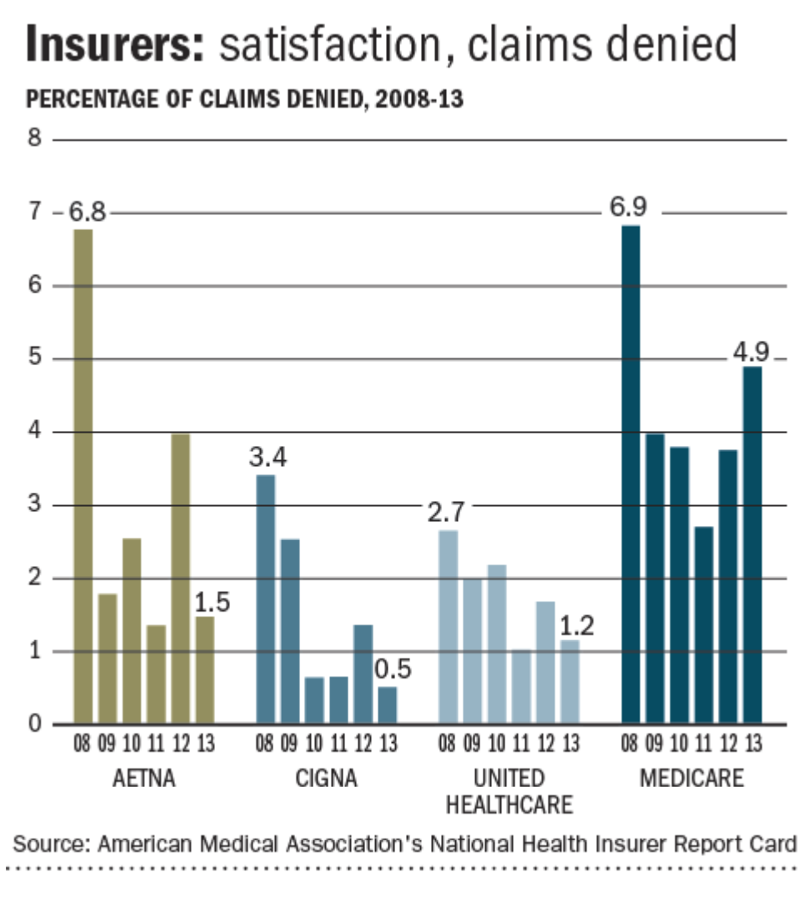

To further understand MSPQ and their connection to organizational revenue, it is important to note that payment for health services often come from 2 or more sources: the patient, the primary insurer and sometimes a secondary and tertiary insurer. The MSPQ determines if Medicare still qualifies to be the secondary payer for the patient. In many cases, this form should be filled out at every single visit, as the primary insurer could change per visit and health issue (Frederick & Leinburger, 2014). The revenue problem created by MSPQs are two-fold: first, it is time consuming for the patient and access representative and secondly, a strong possibility exists for numerous errors to occur during its completion. Then when mistakes are made, Medicare happily denies the claim and revenue is lost for the facility. At this point, the MSPQ returns to the access representative for review and correction. More staffing hours are required at this final stage, to locate the patient and achieve accurate completion of the questionnaire.
As already mentioned, the denial of Medicare claims is a serious issue for MD Anderson. In 2018, Medicare patients accounted for 39.78 % of all revenue for the organization (MDAnderson.org, 2018). The cost of denials makes up an estimated 20% of expenses associated with revenue (Matson, 2018). MD Anderson’s total operating expenses for 2018 were $4,438,334,914.83 (Annual Financial Report), when a 20% estimate of this figure is applied, the total cost is $88,766,698.20 in denials for the year. The hospital estimates that up to 70% of denied claims for the organization stem from Medicare denials (Ahmed, 2017). The department believes that 90% of denial-s are preventable when feedback from denial management is implemented with associated departments (HFMA Texas Gulf Coast Chapter, 2017). According to the American Medical Association (AMA), 25– 30 % of total health care expenditures for the U.S. are from transaction costs and inefficiencies related to the claims management revenue cycle (Becker Hospital Review, n.d.).
Error Examples During MSPQ Completion:
- Questions are read incorrectly.
- Occurrence code on MSPQ was incorrectly matched to issue at hand, on time of visit.
- The “Covered Through” section is filled out incorrectly (e.g., “current employment” is checked when “other” or “retirement” should be selected.
- The patient incorrectly claims that the health issue was due to a work related incident.
- The patient incorrectly says they are entitled to Medicare because of both age and disability. This is impossible as disability ends when the patient turns 65.
- The Group Health Plan patient erroneously reports that they sponsoring employer does not have more than 20 employees (Frederick & Leinburger, 2014).
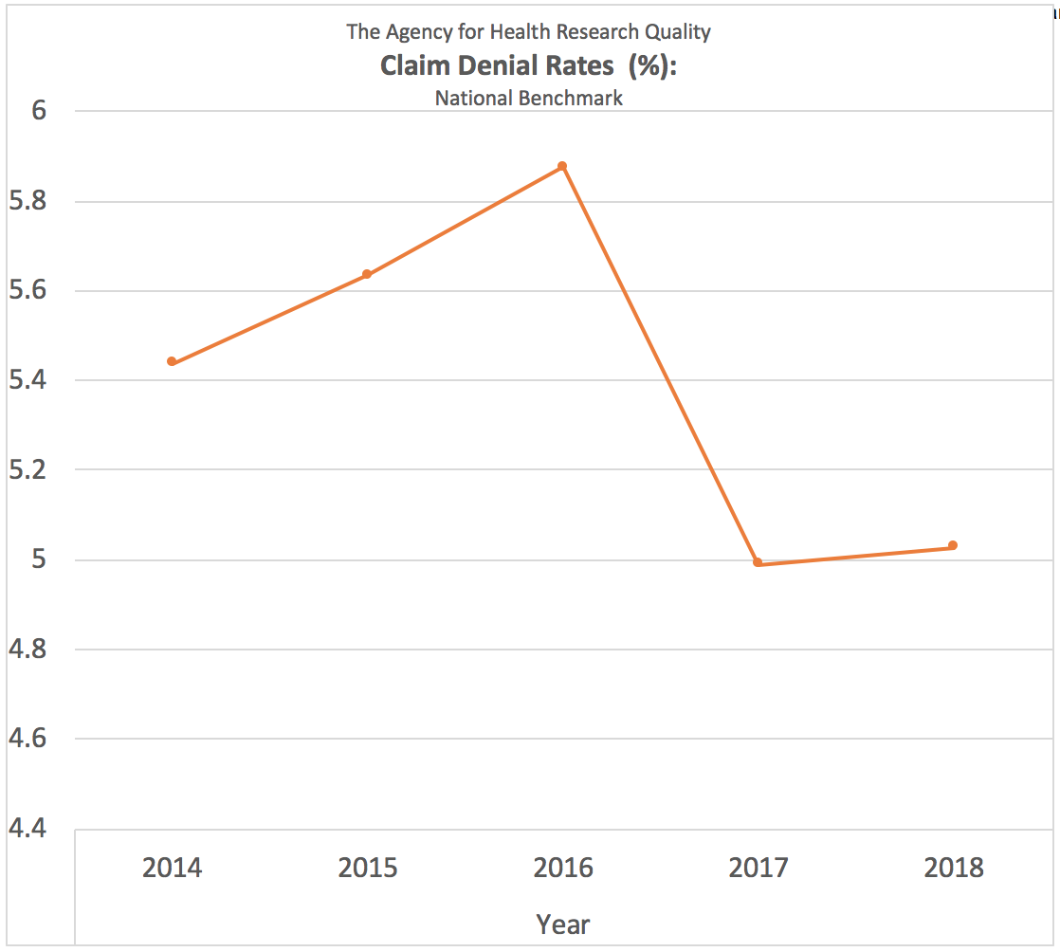
National Benchmark for Hospital Claim Denial Rates:
Leaders within the department have a strong desire to lower the claim denial rate. They all agree that providers should try to keep their claim denial rate at roughly 5% to make certain their organization is maximizing claim reimbursement revenue (LaPointe, 2017). However, MD Anderson has exceeded this rate for the past 5 years.
Claim Denial Rates for MD Anderson’s Lymphoma and Myeloma Clinic:
FY2015 | FY2016 | FY2017 | FY2018 | FY2019
5.268% | 5.993% | 5.982% | 6.023% | 6.78%
*Fictitious data for project purposes only. Release of actual data poses risks amongst competitors.
From the preceding data, leadership has concluded that the department should lower their rate approximately 2%. However, Medicare represents only 70% of this rate and management desires to specifically address Medicare denials at this time. Therefore, a 1.4% reduction is targeted. Other possible variables causing MD Anderson’s claim denial rate do exists. However, as stated, these are not primary causation variables (Ahmed, 2017). For informational purposes, additional causes are:
- The wrongful denial of a claim for insurer’s benefit. This contract breach occurs frequently in the insurance industry and is the reason why insurance attorney’s exist.
- Services rendered to the patient were non-covered charges.
- Pre-authorization notification for treatment was absent.
- Services rendered lacked medical necessity.
- Claims were filed in an untimely manner.
Problem Drivers/Motivators:
- Increase revenue.
- Meet national benchmarking standard.
- Process efficiency improvements.
Organization’s Service Delivery (Operating) System:
MD Anderson has four key operating areas: clinical operations, business operations, research approval systems & therapeutic optimization. Within these areas, the Systems Engineering or Operations department focus on key variables such as: frontline improvement, quality engineering methods, process optimization methods, data mining, human factors and logistics. The Systems Engineering/Operations department for the organization places much focus on the improvement of inefficient systems, making the MSPQ completion system of great interest.
Sub-unit/Department Delivery System Process:
- Scheduling.
- Show up / no show.
- Patient arrives.
- Registration (1st time visit with registration office, following visits begin at department front desk).
- Access representative asks medicare beneficiary or their representative a series of questions (at registration office this is done in an undistracted environment, at following visits this is done at the department's front desk in front of both employees and patients.
- Beneficiary/representative answers these questions.
- Primary payer is determined.
- MSPQ is automatically submitted electronically.
- Registration completed (if at initial visit). Check in is completed (if at following visit).
- Wait time.
- Services rendered.
- Claim approved / denied?
- If denied, patient may receive “surprise bill”.
- If denied, the MSPQ returns to the department’s electronic que for correction.
- Additional labor is employed to identify errors (Medicare will not list them in the denial), contact patient, correct MSPQ and resubmit.
MSPQ Process:
During the MSPQ process, the access representative asks the medicare beneficiary or his/her representative a series of questions designed to rule out any other possible primary payer besides Medicare. If at the end of the questioning, Medicare is not ruled out, then Medicare is determined to either be primary or secondary. The form is submitted, and if filled out accurately, Medicare will approve the claim.
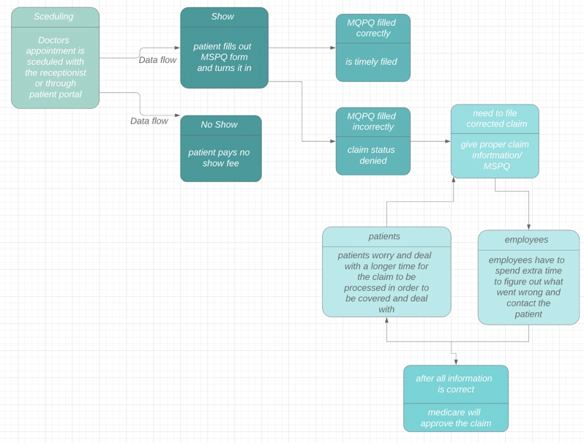
System Constraints
MSPQs are a legislative policy constraint on service delivery for the department. Policy constraints are anything that limits the performance of a system relative to its goal (synchronix.com, 2007). Example policy constraints include legislation, government policy, community expectations and rules imposed by facility owners. (leoisaac.com, n.d.). The questionnaire, and more specifically, its inaccuracies can also be thought about as a bottleneck constraint in the revenue cycle. Bottlenecks are not just a problem for the department’s service level, their effects reverberate throughout the entire organization’s operating system. Bottlenecks also impede maximum output in the service process. MSPQ errors also represent a sub-system constraint, because they occur in a process within a department inside the organization. Lastly, MSPQ errors also represent a resource constraint, since the resource void of valid patient data and employee accuracy are the root constraints on the sub-system.

Cut Diagram

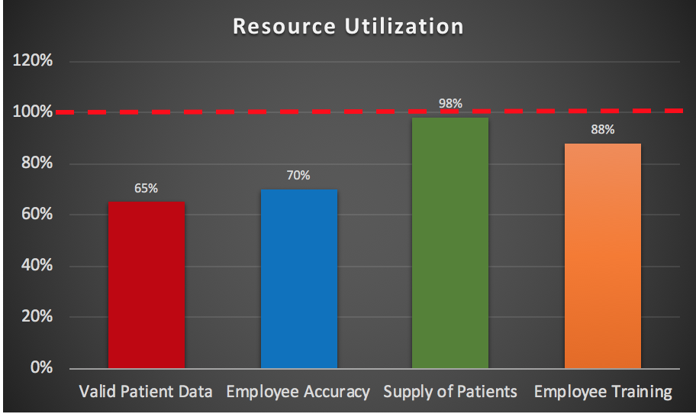

Root- Cause Analysis
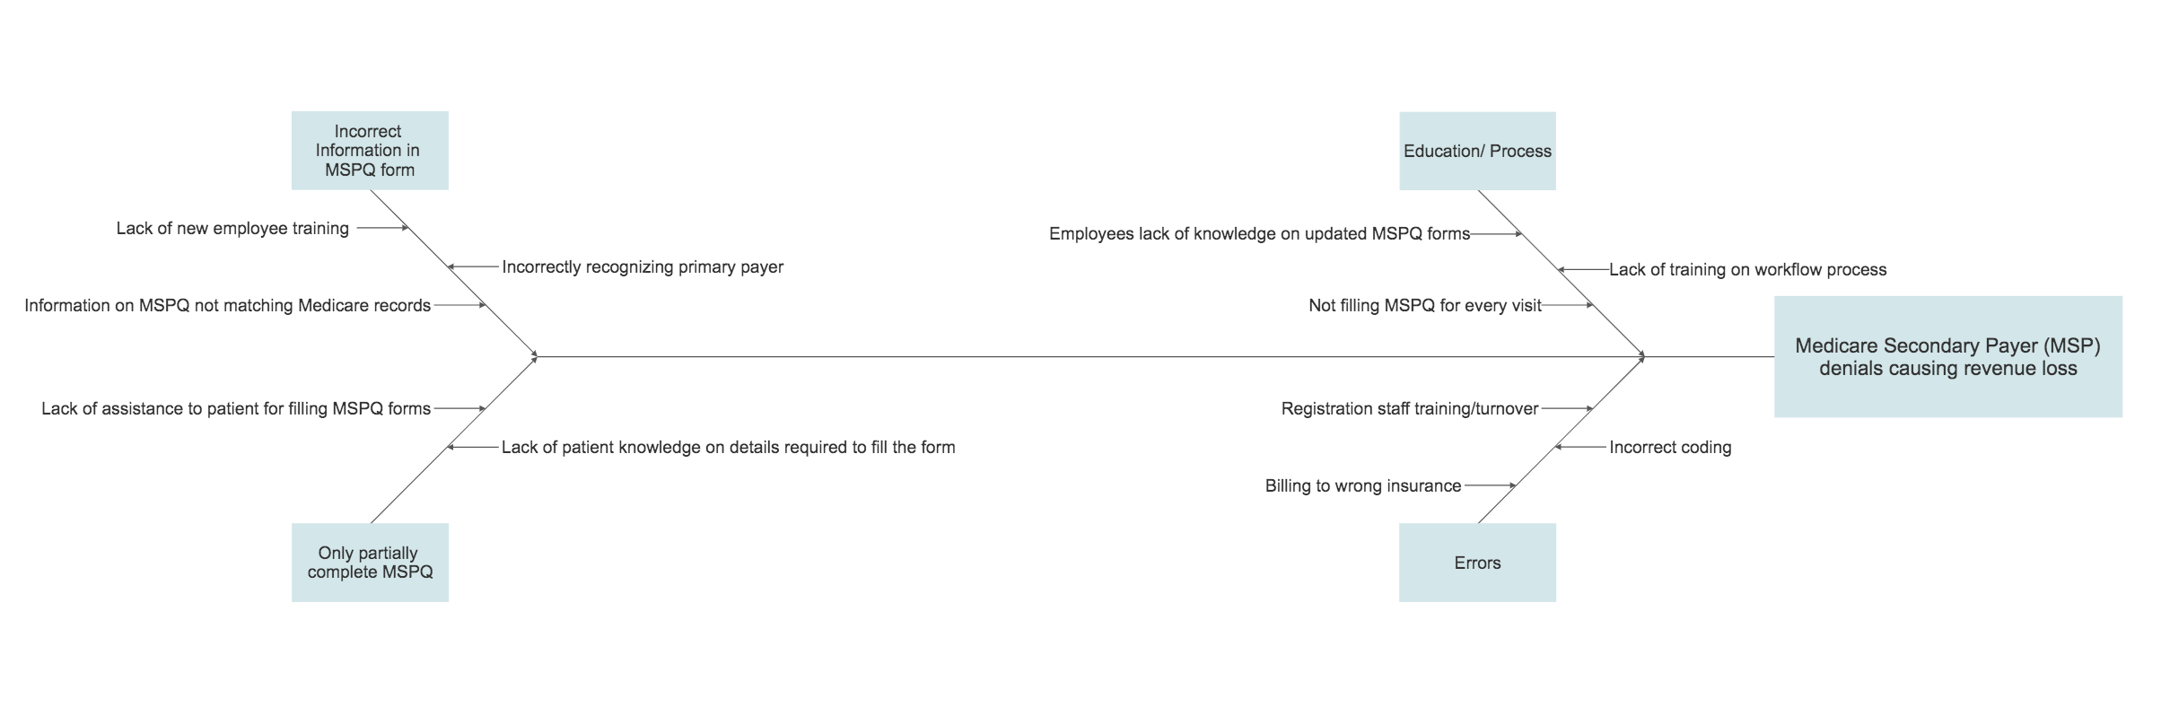
Fishbone diagram showing root-cause analysis
A fishbone diagram helps to visually identify a problem or condition's root causes, allowing to truly diagnose the problem rather than focusing on symptoms. The main problem with the process is loss of revenue due to MSPQ denials. The causes are identified under four main headings:
- Incorrect information on MSPQ forms
The incorrect information on MSPQ accounts from incorrectly identifying Medicare as primary payer for patients with Group Health insurance or other type of insurance (Kevin Wills, 2017). Also, if there is a discrepancy with the information provided in MSPQ and Medicare records, the claims get denied. Lack of employee training on MSPQ can also lead to incorrectly filling the form leading to denial.
- Partially filled MSPQ
If the MSPQ have been partially filled with information on insurance identification, age, disability, end-stage renal disease, practice sessions, and a final assessment it may cause denial. Lack of patients knowledge on MSPQ or lack of assistance personnel in filling out the form can lead to incomplete MSPQ application.
- Lack of education/ process
MSPQ is a requirement for every Medicare patients and have to be filled out every visit. An updated MSPQ needs to be filled out to be accepted by Medicare. Lack of knowledge registration staff on this information can lead to claims getting denied.
- Administrative errors
Administrative errors accounting for claim rejection can be inaccurate coding, billing the wrong insurance, incorrect payments information can lead to MSPQ denials.

Priority factors for Quality Improvement
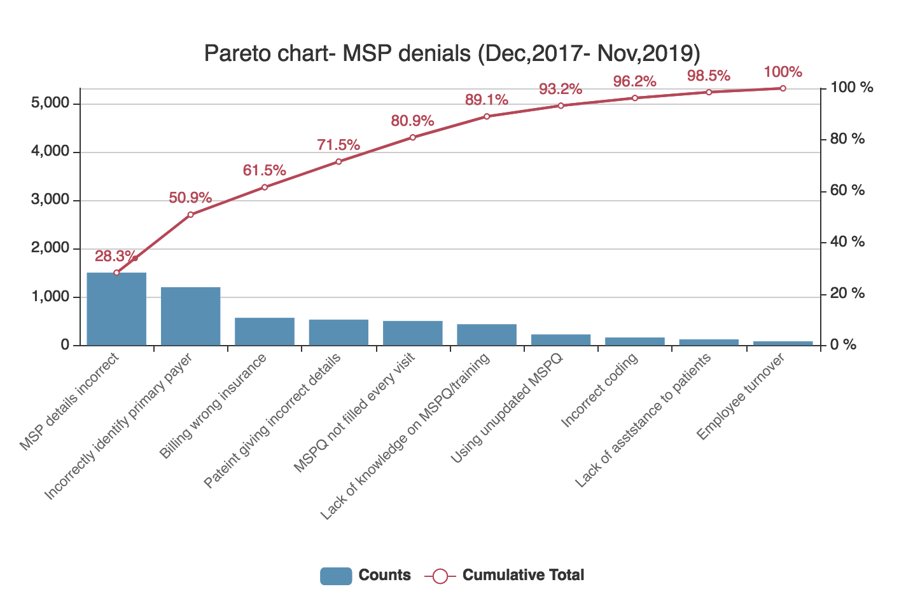
*Fictitious data for project purposes only. Release of actual data poses risks amongst competitors
Looking at the pareto chart, the top five problems make up 80% of the causes for MSP claim denials. The pareto chart would help to target towards the most important problems to identify solutions to improve the process. The top causes that make 80% for MSP denials are:
- Details on MSPQ do not match with the Medicare records.
- Medicare has been incorrectly identified as primary payer.
- Incorrect information leading to billing the wrong insurance company.
- Lack of patient knowledge for filling out the MSPQ.
The target solution will be to first train the registration staff regarding MSPQ process. This will help them learn to gather correct information from the patients to fill out their MSPQ. Also, MSPQ being very confusing, a guide manual or personal assistance would help to correctly fill the MSPQ, rather than go through denial.
Quality Improvement

In order to uphold CMS guidelines, MD Anderson has established an Office of Performance Improvement (OPI). This department’s sole focus is to “utilize quality science to enhance value in the delivery of cancer care through measurable improvement in Safety, Timeliness, Effectiveness, Efficiency, Equity, and Patient-Centeredness” (Performance Improvement, 2019). The OPI sets forth quality indicators that clinical departments can use to measure their respective quality in patient care. These indicators, which are formulated from the CMS guidelines, emphasize patient safety and efficient use of healthcare resources. Therefore, adherence to institutional performance and quality guidelines also indicates compliance with CMS standards.
Quality improvement within the Lymphoma & Myeloma clinic is done using the Clinical Process Analysis (CPA) Program (Performance Improvement, 2019). The CPA technique is an interdisciplinary process that requires hands-on effort from departmental employees and the CPA team (Performance Improvement, 2019). The following diagram provides an overview of the CPA technique.
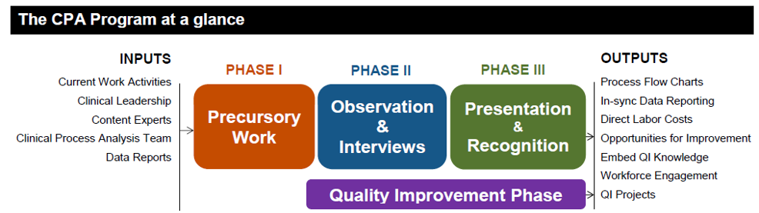
(Performance Improvement, 2019)
Within the Lymphoma & Myeloma department, quality is measured using the aforementioned indicators. The department has one quality assurance (QA) professional that oversees the QA team. Every quarter, three departmental employees are elected to work with this QA individual to conduct quality assurance reviews (Ali, 2019). This QA team compiles data based on the quality measures established by the CMS and OPI. This data is collected by supervisors within the department who then report it to the OPI. Once data is reviewed, departmental leaders in conjunction with the OPI team work to identity and correct indicators that show low performance (Ali, 2019).
Improving the MSPQ falls under the umbrella of a quality improvement project. Therefore, the department would need to engage its QA team to work with QPI team in order to fix this process. Quality improvement projects are handled using various data analysis and process optimization techniques, such as Lean and Six Sigma (Healthcare Systems Engineering, 2019). Industrial engineers specialized in healthcare systems are assigned to these projects to oversee execution of QI techniques (Healthcare Systems Engineering, 2019). A recommended technique to use in this particular project is Plan-Do-Study-Act. The diagram below details the PDSA model. The succeeding chart applies the PDSA model to the MSPQ project improvement. Given that issues in MSQP completion are caused by incorrect patient answers, any QI project aimed at decreasing the Medicare denial rates must address the patient’s role in the process.
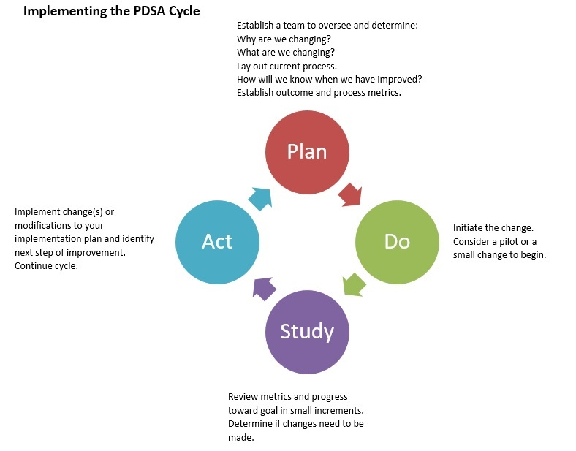

Plan | Do
- Objective: Reduce MSPQ denials within the Department of Lymphoma and Myeloma by 10% for FY 2020  - Teams: QPI and departmental QA team  - Metrics: Revenue and MSPQ denial rate | - Train front desk personnel so they are aware of the MSPQ process and are more receptive to catching errors in patients’ answers.
Study | Act
- Review denial rates and track revenue flow after implementation to track any changes  - Determine if the metics show a promising change or if further intervention is required | - Modify the training technique or implement another course of action based on metric data

Evaluation of the Improvement in Service Delivery Processes
There are several benefits of using control charts as a tool to support quality improvement for any organization, specifically healthcare. Control charts assess amounts of variation within a range and provide visual cues to help viewers interpret data based on upper and lower control limits. Run charts are annotated by actions taken and put data in context for the viewer. This allows staff to follow implementation of any interventions needed ("Quality Improvement in Healthcare: 5 Guiding Principles", 2019).
For the past five years, revenue has seen a downward trend at MD Anderson Cancer Center. Specifically, the increased pattern of MSPQ claim denials has played a significant role in this matter.

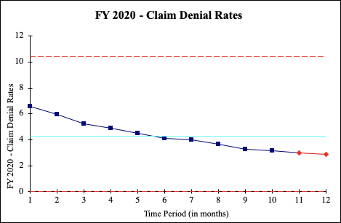
*Fictitious data for project purposes only. Release of actual data poses risks amongst competitors.
According to the control chart above, in Fiscal Year 2020, the claim denial rates were significantly reduced over a 12-month period based on the solutions implemented. Detailed data of reduction rates are listed as follows:
Time Period (months) | Claim Denial Rates (percentages)
1 | 6.56
2 | 5.98
3 | 5.24
4 | 4.87
5 | 4.5
6 | 4.1
7 | 3.97
8 | 3.64
9 | 3.28
10 | 3.15
11 | 2.99
12 | 2.85
While these statistics are used to describe the data, inferential statistics allow you to make predictions using the data to measure the effectiveness of specific solutions. The goal was to significantly reduce MSPQ denials in the Department of Lymphoma and Myeloma by FY 2020, and that goal was achieved.

Variables For Performance Measures
- Net Income

- EBIT (Earnings Before Interest and Taxes)
  - EBIT = Net Income + Interest + Taxes
- EBITDA (Earnings Before Interest, Taxes, Depreciation and Amortization)
  - calculated by subtracting all expenses except interest, taxes, depreciation, and amortization from net income
- EPS (Earnings Per Share)
  - subtracting preferred dividends from net income and dividing by the weighted average common shares outstanding
- P/E Ratio (Price to Earnings Ratio)
  - dividing a company's current stock price by its earnings per share
- Return on Equity (ROE)
  - ROE Ratio = Net Income/ Shareholder's Equity
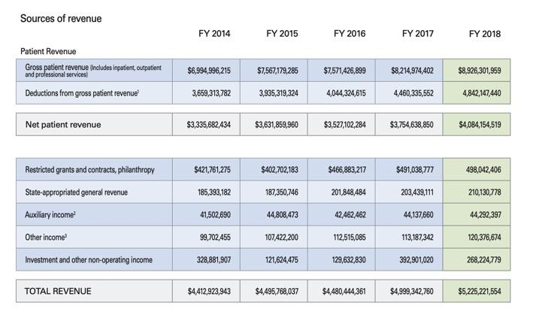

Other Areas Of Improvement
The Supply Chain for this process starts off with patients scheduling their doctors appointment. When the patient shows to the office, he or she is asked to fill out questionnaires. Instead of the employee trusting what the patient wrote, the employee should help out the patient and see if everything was filled out correctly to avoid any future mistakes, so the employee can do this by discussing the form in a private room. This way, the claim denial rates will go down, and both employees and patients will not have to put in extra time and effort to figure out what went wrong. This will save both the employee and patient time and energy.
Solutions
There are certain factors that MD Anderson can hold into account to make this process run more efficiently. For instance, there can be weekly audits on MSPQ completing employees and note errors to figure out if there are any trends that are hindering the incorrect or incompletion of the form. This can help prevent the errors from recurring and prepare the depart for CMS (Center for Medicare & Medicaid Service) audits. Through this, certain errors or inconsistencies can be identified to see which questions are complex and often result in inaccuracies. Employees may use process in theory of constraints to identify - exploit - subordinate - elevate - repeat the problem. Repetition is necessary because the theory of constraints states that if you remove a constraint from one place it will show up somewhere else. Employees may also be trained to offer guidance instead of merely reading questions verbatim and explain to patients why their information is needed. Employees should feel free to interpret patients’ responses instead of simply recording what they say. They can also isolate access representatives, reorganize job tasks and reduce interruptions so that the patient can focus on quality MSPQ completions. Usually, receiving proper completion for MSPQ can be an issue for patients since it is tedious for patients to be asked the same questions over and over again. The form is 8 pages long and there is room for plenty of mistakes to be made. Questions can easily be read incorrectly. There can also be a restructure denial management approach to prevent denial approach, so the patients payments do not continue to get declined. Patients may also utilize the “Model Admission Questions for Medicare Beneficiaries - 20.2.1” section of the CMS MSP Manual, to ensure more efficient evaluation. With the implementation of these changes, the denial rates of those that identify Medicare as Secondary Payer will decrease.
Conclusion
MD Anderson is a world-renowned cancer treatment center. The institution's lymphoma and myeloma department has made strides in creating therapies for specific lymphomas. Despite ground-breaking research trials and highly skilled physicians, the department has its own issues. Decreased revenue due to claims denials is a major problem for the department. These denial rates can be decreased by targeting errors in the MSPQ process. Through a dedicated quality improvement team and a defined improvement process, decrease in denial rates is possible. Quality improvement is not a one-time effort. In order for changes to be meaningful, they must be monitored to ensure that there is a positive impact. Therefore, after implementing an improved MSPQ process, the department must track revenue and other targeted value drivers to ensure that denial rates show steady improvement in FY2020

References
Ahmed, (2017) Fictitious data for project purposes.
Dahmen, R. (n.d.). Implementing an Effective Denials Management Program. Implementing an Effective Denials Management Program. Eide Bailley. Retrieved from https://www.beckershospitalreview.com/pdfs/April_30th_Saturday/1115_F_Dahmen_Denials Management Reducing and Eliminating Claim Denials Utilizing Best Practices.pdf
Frederick, E. & Leinburger, L. (2014) MSPQ Secondary Payer Questionnaire Video. Retrieved from: https://www.youtube.com/watch?v=Ud-akjFFCuk
Gaffney, J. (2017). Managing Denials in Large Health Systems. Managing Denials in Large Health Systems. PWC. Retrieved from: https://www.hfmatxgc.org/wp-content/uploads/2015/05/1706-Gaffney.pdf
Isaac, L. (n.d.). Policy Constraints. Retrieved from:
http://www.leoisaac.com/policy/top124.htm.
Jackson, S. (2007). Theory of Constraints: Policy Constraints: 5 Steps. Retrieved from https://www.synchronix.com/toc_exploit_subordinate_elevate.htm.
Kevin Wills, 2017, Incorrect or Incomplete MSPQ? Either Way, It’s Lost Revenue. Retrieved from:https://www.reliasmedia.com/articles/141107-incorrect-or-incomplete-mspq-either-way-its-lost-revenue
LaPointe, J. (2017, March 10). Top 4 Claims Denial Management Challenges Impacting
Revenue. Retrieved December 9, 2019, from
https://revcycleintelligence.com/news/top-4-claims-denial-management-challenges-impacting-revenue.
Olin, A., & Clarke, M. (2016). 75 Years of Patient Care Research Prevention Education
Making Cancer History. 75 Years of Patient Care Research Prevention Education Making Cancer History. University of Texas. Retrieved from https://www.mdanderson.org/documents/publications/annual-report/FY16 Annual Report FINAL 050917.pdf
Quality Improvement in Healthcare: 5 Guiding Principles. (2019). Retrieved 12 December 2019, from https://www.healthcatalyst.com/insights/quality-improvement-healthcare-5-guiding-principles
S.E.C. (2019), Fictitious data for project purposes.
The University of Texas, MD Anderson. (2018). Fy 2018 Annual Financial Report. FY 2018 Annual Financial Report. Retrieved from https://www.mdanderson.org/content/dam/mdanderson/documents/about-md-anderson/about-us/ut-system-reports/Annual Financial Report/2018-AFR.pdf
Twedt S. (2014) How do national health insurers compare on denying claims? Gazette. Retrieved from: https://www.post-gazette.com/business/healthcare-business/2014/11/13/National-insurers-compete-for-foothold-in-Pittsburgh-market/stories/201411130178. Published November 12, 2014. Accessed December 9, 2019.
MD Anderson. (2017). Quick Facts About Md Anderson. Quick Facts About MD Anderson. Retrieved from https://www.mdanderson.org/documents/about-md-anderson/about-us/facts-and-history/QF2017_SingleSpreadCombo_FINAL.pdf
What Is Market Constraints. (n.d.). Retrieved from https://www.igi-global.com/dictionary/thinking-inside-the-box/56774.
https://www.mdanderson.org/research/departments-labs-institutes/departments-divisions/lymphoma-myeloma.html
AHC MEDIA. (2018). The MSPQ Chess Match: No Conversations Alike. Hospital Access Management, 37(12), 0. Retrieved from http://search.ebscohost.com.ezp.twu.edu/login.aspx?direct=true&db=ccm&AN=133067331&site=ehost-live
Incorrect or incomplete MSPQ? either way, it’s lost revenue.(2017). Hospital Access Management, 36(8) Retrieved from ProQuest Business Collection (Alumni Edition) database. Retrieved from https://search.proquest.com/docview/1985653436
MD Anderson. (2019). Quick Facts About Md Anderson. Quick Facts About MD Anderson. Retrieved from https://www.mdanderson.org/documents/about-md-anderson/about-us/facts-and-history/quick-facts.pdf

